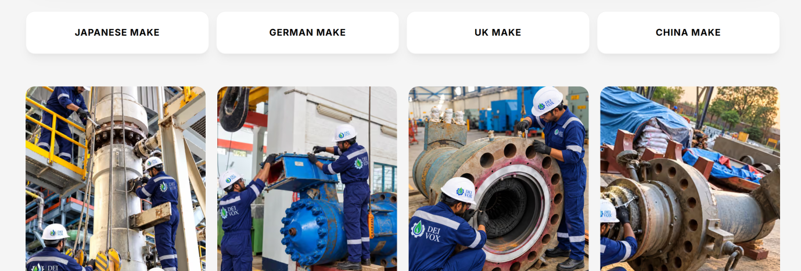
Change sequence: 1st is UK MAKE, 2nd JAPANESE MAKE, 3rd CHINA MAKE, 4th GERMAN MAKE

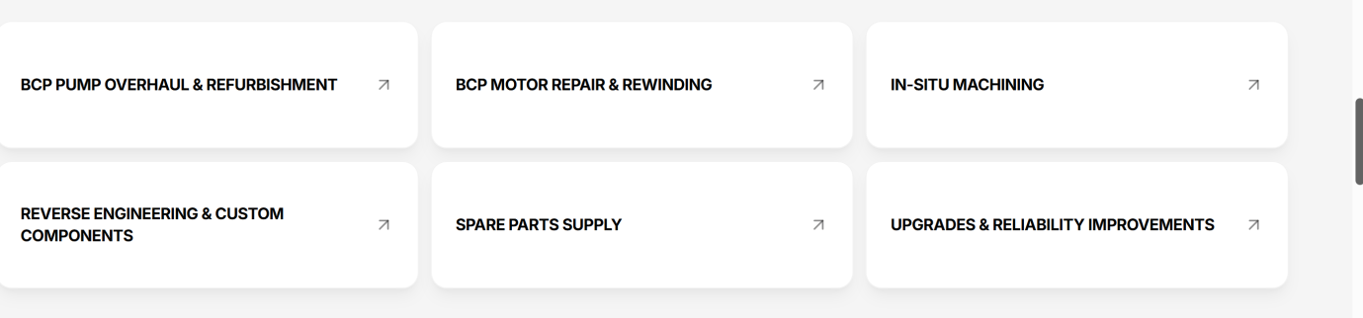
CORRECT THE PAGE LINKAGES
+
REMOVE INSITU MACHINING, ADD TESTING AND QUALITY
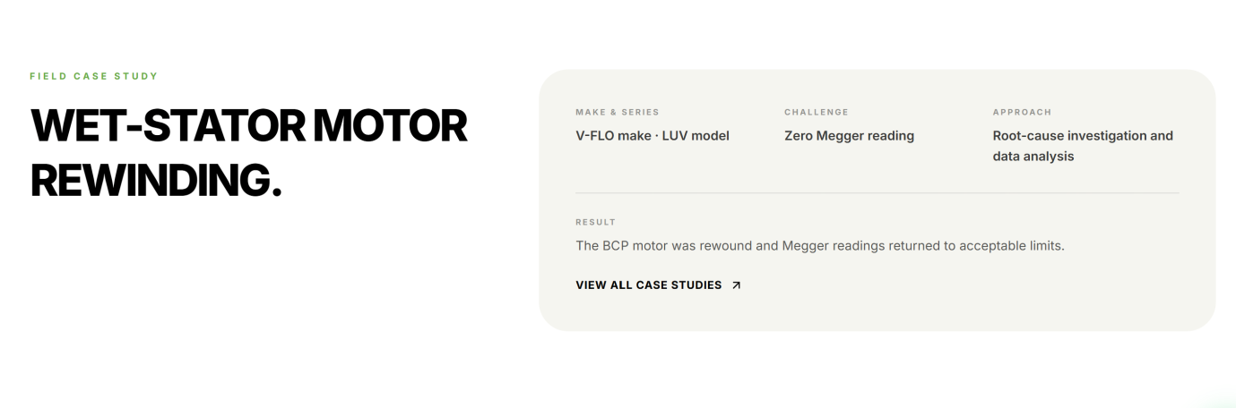
DELETE THIS SECTION ON MAKE AND MODEL PAGE
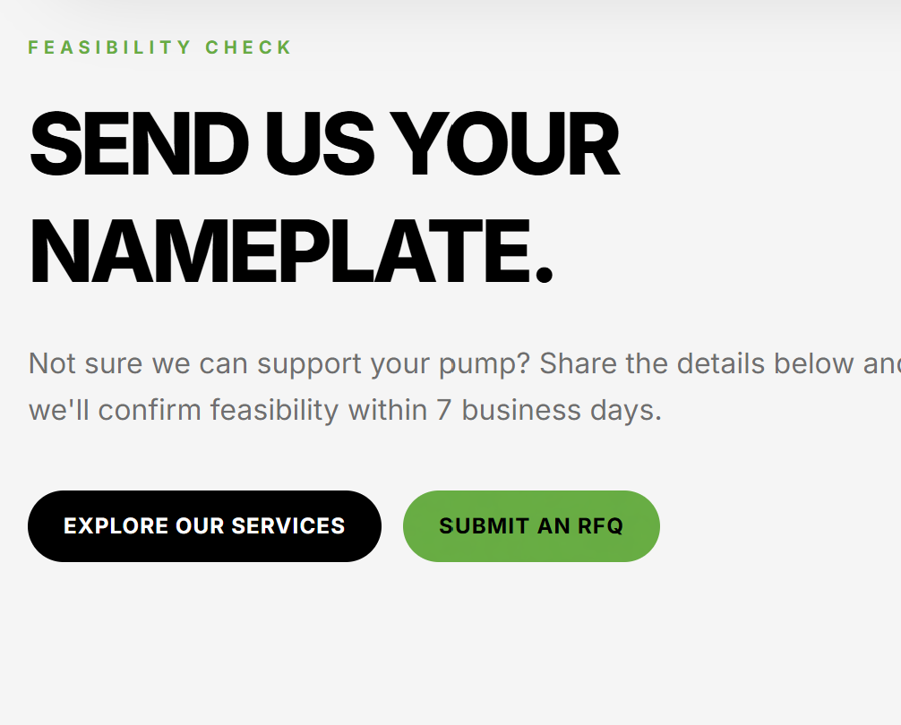
EXPLORE OUR SERVICES – GIVE LINK TO – SERVICES OVERVIEW

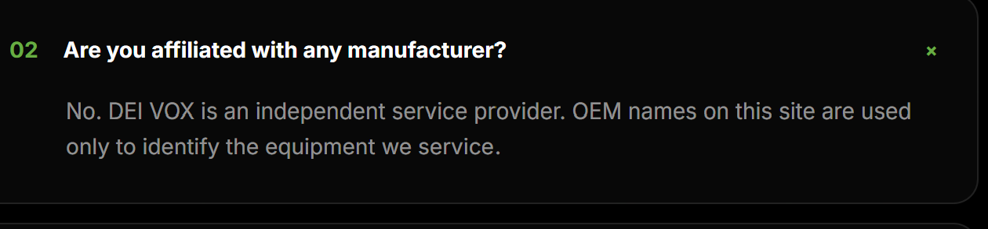
ADD BELOW LINES:
DEI VOX India Pvt. Ltd. is an independent, multi-make BCP aftermarket service provider and is not affiliated with or endorsed by any OEM. All third-party intellectual property, including trademarks, logos and images, remains the property of its respective owners. References to pump origins and designs are for identification and technical reference purposes only.

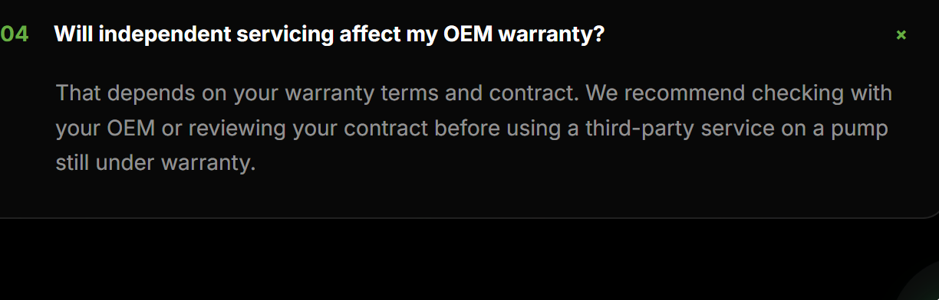DELETE THIS QUESTION.

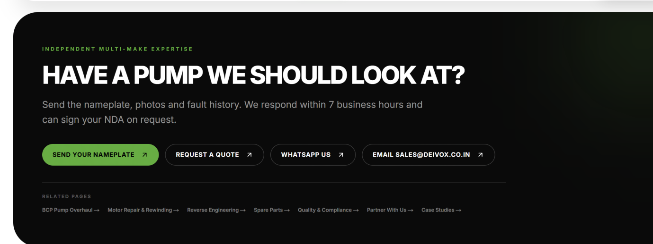
CORRECT ALL RELATED PAGES LINKS TO RESPECTIVE NEW PAGES

